Name: _______________________ Class: __________ Date: _______
Instructions: Write answers in the right-hand column. Score: ___________ / 47 marks

Section A—Multiple choice (10 marks)

 | Which one of the following statements is INCORRECT?  A Liquids and gases are both fluids and they can be poured.  B Solids and liquids have a definite volume but gases have a variable volume.  C Solids are incompressible but liquids and gases are highly compressible.  D Solids have a definite shape, but liquids and gases have variable shapes. | C | 1
 | A gas is confined in a cylinder with a movable piston at one end. Assuming the temperature remains constant, if the piston is pushed in, which of the following statements about the volume and pressure of the gas is correct?  A The pressure will remain unchanged.  B The pressure will increase because the volume is increasing.  C The pressure will decrease due to the increase in volume.  D Because of the decrease in volume, the pressure will increase. | D | 1
 | A flask contains equal masses of two gases, hydrogen and nitrogen, at a temperature of 30⁰C. Which of the following statements about these gases is NOT correct?  A The average kinetic energy (½mv²) of the molecules of both gases is the same.  B The average velocity of the H₂ molecules is greater than the average velocity of the N₂ molecules.  C There are more H₂ molecules than N₂ molecules in the flask.  D The pressure exerted by the H₂ molecules in the flask is less than the pressure exerted by the N₂ molecules. | D | 1
 | Increasing the volume of a given amount of gas at a constant temperature causes the pressure to decrease because:  A the molecules are striking a larger area with the same force.  B there are fewer molecules.  C the molecules are moving more slowly.  D the molecules are hitting the wall with a smaller force. | A | 1
 | Which of the following liquids has the highest vapour pressure?  A pure water at 20⁰C  B sea water at 40⁰C  C pure water at 40⁰C  D ethanol (boiling point 78⁰C) at 40⁰C. | D | 1
 | Which one of the following statements is true?  The temperature at which ethanol boils:  A gradually increases as the ethanol boils away  B depends on room temperature  C decreases if the atmospheric pressure falls  D decreases if a small amount of water is added to it. | C | 1
 | Which of the following statements about solutions are true?  i When sodium chloride is dissolved in water, the water is the solute.  ii An unsaturated solution contains more solute than is needed to saturate it.  iii A supersaturated solution contains less dissolved solid per unit volume than a saturated solution.  iv In general, the solubility of a gas in a liquid decreases with increasing temperature.  v When sodium nitrate dissolves in water, dissociation occurs.  A ii, iii and iv  B i, ii and iv  C ii and v  D iv and v. | D | 1
 | Which of the following pairs of solutions would not form a precipitate when mixed together?  A magnesium chloride solution and potassium sulfide solution  B zinc chloride solution and potassium phosphate solution  C calcium chloride solution and copper(II) nitrate solution  D lead nitrate solution and iron(III) iodide solution. | C | 1
 | Barium nitrate and barium chloride were mixed in water to form a solution X. Sodium carbonate and potassium chloride were mixed in water to form a solution Y. When X and Y were mixed, a white precipitate was formed. What is this white precipitate?  A barium sulfate  B barium carbonate  C sodium chloride  D potassium carbonate. | B | 1
 | Of the following solutions, which would be best classified as a concentrated solution of a weak electrolyte:  A 0.10 mol L^{–1} nitric acid  B 6.0 mol L^{–1} potassium hydroxide  C 5.0 mol L^{–1} acetic acid  D 1.0 mol L^{–1} sugar. | C | 1

Section B—Written answers (37 marks)

 | a Use the assumptions of the kinetic theory of gases to explain why raising the temperature of a constant mass of gas, at constant pressure, will result in an increase in the volume occupied by the gas.  b Sketch an equipment set-up that could be used to demonstrate the property of gases described in part a. Label your diagram clearly.  c Describe how the pressure would be kept constant in the equipment set-up you have sketched in part b. | a When the temperature of a sample of gas is increased, the average kinetic energy of the particles in the gas is increased. This means that the particles are exerting a larger force on the surface of the container in which they are held. If the pressure is to remain constant, the larger force needs to be spread over a larger surface area. In other words, the volume of the container must increase.  b 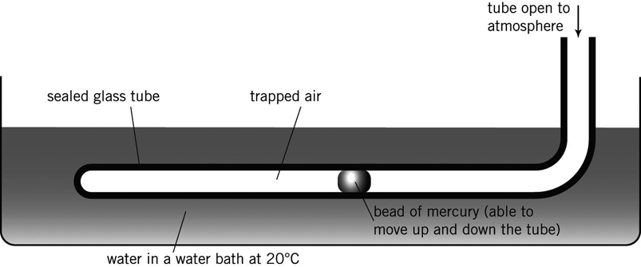  c In the apparatus drawn, the pressure is kept constant by allowing the mercury in the tube to move as the temperature of the gas trapped in the tube is increased. When the mercury stops moving the pressure of the gas in the tube is the same as atmospheric pressure. Provided that atmospheric pressure does not change during the experiment, the apparatus allows the investigation of change in volume with temperatures at constant pressure. |  | 6
 | Sketch a graph that shows the relationship between pressure (vertical axis) and temperature, in degrees Celsius, (horizontal axis) for a particular amount of gas at a constant volume. | 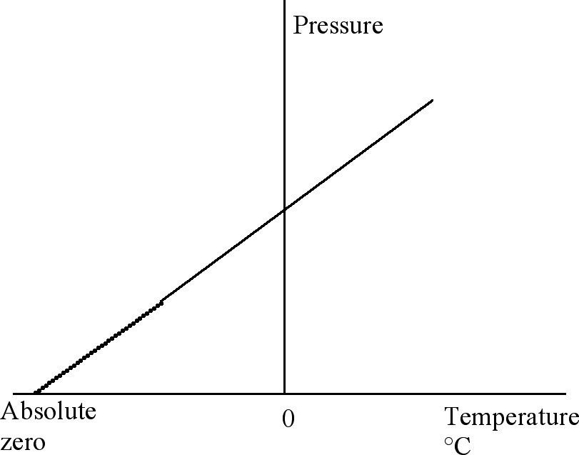 |  | 2
 | This heating curve shows the changes in temperature that occurred during the heating of a solid, as it melted and finally boiled.  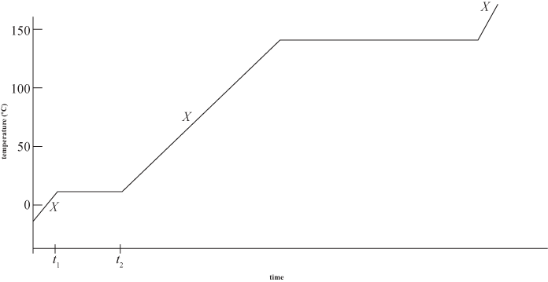 |  |  | 6
 | a What is the approximate boiling point of the substance?  b Indicate on the graph one time when the kinetic energy of the substance is changing but its potential energy is remaining approximately constant.  c During times t₁ to t₂, despite the substance being heated, its temperature is remaining constant. Explain this observation.  d Would you expect the substance being heated to be tribromomethane (CHBr₃) or sodium bromide? Explain your reasoning. |  | a 140°C  b Marked with an X (any one)  c As the solid is melting, the heat energy is being used to disrupt the bonds between the particles (molecules) in the solid rather than to change their kinetic energy. Since the kinetic energy is not changing (but the potential energy is), the temperature of the substance does not change.  d Tribromomethane – because this is a covalent molecular substance which is expected to have relatively low melting and boiling points. Sodium bromide is ionic and its melting and boiling points would be much higher than shown on the graph. Much more energy is required to break the strong ionic bonds in the lattice of positive and negative ions in sodium bromide, compared to the energy required to break the weak bonds between the neutral tribromomethane molecules. | 6
 | Using the kinetic theory of matter, explain why washing hanging on a clothes line will dry quicker on a hot day than on a cold day. | The rate of evaporation of liquid depends on the temperature. Since temperature is a measure of the kinetic energy of the particles, at a higher temperature there will be more molecules in the liquid with enough kinetic energy to break away from the liquid and enter the gas phase. |  | 2
15 | During operation, the pressure in the radiator of a car is considerably higher than atmospheric pressure. Explain why it is dangerous to remove the radiator cap when the engine is still hot. | The increased pressure in the radiator of the car allows the water to be heated to a temperature greater than 100°C without boiling. If the radiator cap is removed while the temperature of the water is higher than 100°C the rapid decrease in pressure from that in the radiator to atmospheric pressure will cause the water to boil violently. The resulting steam or water that will ‘burst’ from the radiator, at temperatures in excess of 100°C, can cause severe burns. |  | 2
16 | When gaseous HBr is added to water, the solution formed is a very good conductor of electricity. However, when liquid CH₃OH is added to water, the solution formed does not conduct electricity. Explain these observations. | When HBr is added to water it reacts with the water and undergoes complete ionisation (it is a strong electrolyte).  HBr(g) + H₂O(l) → H₃O⁺(aq) + Br–(aq)  (or HBr(g) + aq → H⁺(aq) + Br–(aq)  The presence of ions in solution makes it a good conductor.  When methanol dissolves in water there is no reaction because methanol is a non-electrolyte. The methanol molecules simply mix with the water molecules and no ions are formed. |  | 4
17 | Describe what you would expect to see when the following pairs of solutions are mixed:  a a solution of cobalt nitrate and a solution of sodium carbonate  b a solution of zinc chloride and a solution of calcium nitrate  c a solution of lead nitrate and a solution of potassium sulfate  d a solution of iron(III) chloride and a solution of sodium hydroxide. | a A pink solution is added to a colourless solution and a pink solid forms.  b Two colourless solutions are mixed and there is no noticeable change.  c Two colourless solutions are mixed and a white solid is formed.  d A colourless solution is added to a brown solution and a brown solid is formed. |  | 4
18 | What mass of K₂SO₄ would be contained in 208 mL of 0.910 mol L^{–1} K₂SO₄ solution? | n(K₂SO₄) = cV  = 0.910 × 0.208  = 0.1893 mol  m(K₂SO₄) = n × M  = 0.1893 × 174.26  = 33.0 g |  | 2
19 | 0.200 moles of solid MgCl₂ are added to a 1.20 L of 1.40 mol L^{–1} NaCl solution.  a Calculate the concentration, in mol L^{–1}, of Cl– ions in the ‘new’ solution.  b What assumptions have been made in this calculation? | a n(Cl–) from MgCl₂ = 0.400 mol  n(Cl–) from NaCl = cV  = 1.40 × 1.20  = 1.680 mol  total amount of Cl– = 2.08 mol in a  volume of 1.20 L  concentration of Cl– = 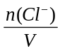  =  = 1.73 mol L^{–1}  b Assumptions include:  – the volume of solution does not change  – all the magnesium chloride dissolved  – there is no other reaction between magnesium chloride and sodium chloride. |  | 5
20 | The health authorities in Australia recommend the safe level of lead in drinking water to be 0.01 ppm (1 ppm of lead = 1 mg of lead dissolved in 1kg of drinking water). Despite lead and its compounds being very toxic, products used every day, such as car batteries, still contain lead. Lead and many of its compounds are insoluble in water, so it is assumed that very little lead enters the drinking water supply by the dissolution of lead substances. Lead(II) oxide, a compound regarded as insoluble in water, is used to make crystal glassware and as a pottery glaze. The solubility of lead oxide at 25ºC is 0.002 g per 100 g of water. If some water is stored in a bowl of crystal glass, determine whether this water could possibly dissolve sufficient lead oxide to raise the level of lead in the water over the recommended safe level. | 0.002 g of lead oxide per 100 g of water is equivalent to 0.02 g of lead oxide in 1000 g (1 kg) of water.  n(PbO) = 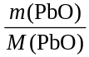  =  = 8.96 × 10^{–5}  = mol of Pb in 0.02 g of lead oxide  m(Pb) = 8.96 x 10^{–5} × 207.2  = 0.019 g = 19 mg  Hence, there is 19 mg of lead in 1 kg of water which is 19 ppm of lead. This is above the recommended safe level. |  | 4

